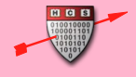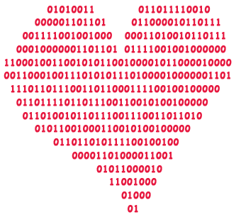

February 7th

Anyone with a Harvard email is

eligible for true love!\*\*

\* Nothing is binding, but why not take a chance on us…?

\*\* Undergrads are guaranteed to be matched with undergrads, and grads are guaranteed NOT to be matched with undergrads!

Presented by The Harvard University Computer Society

1. Sign up at datamatch.hcs.harvard.edu
2. Fill out our 30 question survey
3. Sit back and relax as we send you a list of top 10 matches\*

Finding your true love

is as easy as 1-2-3

Datamatch

Valentine’s